**Bacnet/MSTP Adapter Setup**

**I. Wiring connections:**

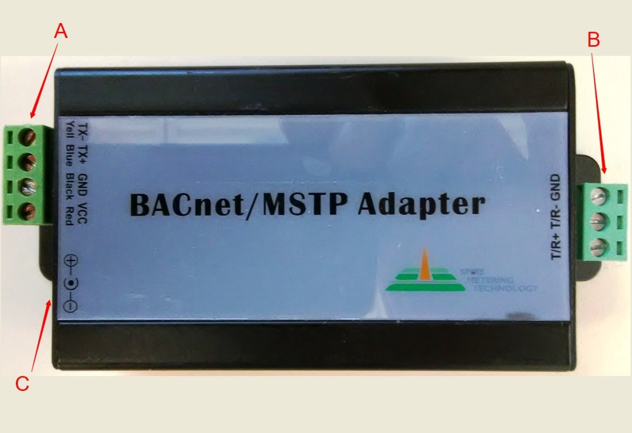

Description of ports:

**A** Contains four ports at the top left corner which are from top to bottom：

TX485- (Yellow) TX485+ (Blue) GND (Black) VCC(9VDC to 12VDC out) (Red)

These ports connect to Meters with the RS485 interface.

**B** Connects to a RS485 BACnet interface: GND, T/R - and T/R+ (usually to a concentrator).

**C** Is a round jack for the power supply voltage in (9 VDC to 12 VDC in), this powers the device and supplies the VCC output voltage on **A**.

Wiring connection example:



**Ⅱ.** **BACnet Subassembly**：



**Ⅲ. MAC Address of BACnet**

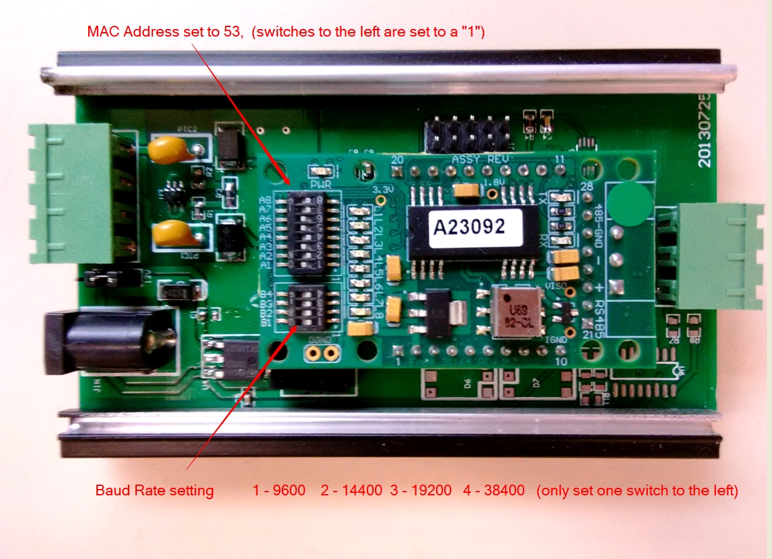Instructions：

1. The *default* MAC address is 0. The above module has been set to 53, which in binary

is (00110101). The address is set by turning on each bit to match the ID number

you require.

Switch A8 ---------------to---------------A1

128 64 32 16 8 4 2 1

0 0 1 1 0 1 0 1

32 + 16 + 4 + 1 = **53**

2. The *default* baud rate for the BACnet ***output*** is set to 0, and must be set to your intended baud rate. To set the baud rate select only **one** switch from the following list:

B4 – 76800

B3 – 38400

B2 – 19200

B1 – 9600